MEDICAL-IMAGES PROCESSING USING FRACTAL PROPERTIES

Daniela Alexandra Crisan¹⁾, Cătălina Popescu-Mina²⁾, Justina Lavinia Stanica¹⁾, Catalin Dimon³⁾

¹⁾ Romanian-American University, Bucharest
Bd.Expozitiei nr.1B, sector 1, Bucharest, Romania
dacrisan@yahoo.com
²⁾ University of Bucharest, Bucharest, Romania
³⁾ “Politehnica” University of Bucharest, Department of Automatic Control and Computer Science
313 Splaiul Independentei, 060042, Bucharest, Romania

Abstract - In this paper it is investigated how fractal properties can be used to characterize a mammographic lesion. The idea is suggested by the similarity between the breast tissue and a synthetically generated fractal image. Fractals are pertinent tools to describe the complexity of a shape; meanwhile, radiologists use the complexity of the lesion’s contour to classify the abnormality. Tests on 30 cases mammographic lesions shows that fractal dimension of the lesion’s contour is higher in cancer cases and lower in benign cases. This could be an important observation in order to classify BI-RADS 4 lesions, with no need of further examination (biopsy).

Keywords – Fractal, Fractal Dimension, Box-Counting Algorithm, Image Processing, CADM

INTRODUCTION

Around the year 1970, the French mathematician Benoit Mandelbrot introduced the concept of fractals in order to describe some dynamic systems. Although Mandelbrot named these features as fractals, other mathematicians have studied those forms years before: Cantor, Sierpinski and Koch were attracted by the strange properties of these forms around the beginning of the XIX century. In 1918, the German mathematician introduced the fractional dimension.

Mandelbrot defined a fractal as a form with self-similarity a form composed by copies transformed of himself [1]. In addition, as one looks more deeply or more closely at a fractal, its inner parts have a similar design to that of the whole object [2].

Later Mandelbrot proposed another definition: a fractal is a form with a fractional (non-integer) dimension.
In the last decades, many researchers concerned their attention on fractals properties of objects. Fractals can be use to describe natural shapes, so their applications are various in many fields such as informatics, economics, engineering, medical screening [3, 4].

Breast cancer is the most common women disease in modern world; statistics shows that a woman’s lifetime risk of developing breast cancer is 1/8. Mammography is the most efficient tool for detection and diagnosis of breast lesions. In the last decades, medical exams became a regular act; thus, the amount of mammograms interpreted by a radiologist increase dramatically. As a result, a focused effort initiated two decades ago, is under way to develop a Computer-Aided Diagnosis of Mammograms (CADM).

One of the most important components in a CADM is to classify the lesion. The similarity between the breast tissue and synthetically generated fractals suggests that fractal properties, such as fractal dimension, may be used as a classifier [5].

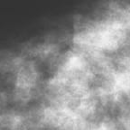  (a) | 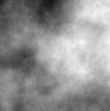  (b)
Fig. 1. The similarity between the breast tissue (a) and synthetically generated fractals (b)

FRACTALS

Fractal space

An essential property of a fractal object is that its size depends on the size unit used to measure it; as a result, measuring a fractal object into an Euclidian space is not relevant. Consider a famous fractal: the Koch Snowflake obtained by repeating for an infinite times the procedure: a straight line is divided into three equal parts, the middle part becomes the base of a triangle, then is eliminated.

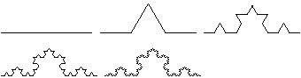

Fig. 2. A famous fractal: the Koch Snowflake, having infinite length and 0-aria.

Considering that the Koch Snowflake is an one-dimension Euclidian figure, its measure will provide no information: it will be infinite (if the starting line have 1 unit length, the second form will be 4/3 length, the n-figure will be (4/3)^{n-1}, and for will have infinite length). Considering it as a two-dimension Euclidian figure, its size, this time the aria, will be null. So, it is necessary to imagine a non-integral dimension space into which the size of the Koch Snowflake will not be null or infinite. This is a fractal space, meaning a non-integral dimension space, dimension known as fractal dimension.

Self-similarity dimension, Hausdorff dimension and box-counting algorithm

The self-similarity dimension is based on the self-similarity property of a fractal object, the object being covered with copies of itself on other scale. It is a way to compute analytically the dimension of fractal space:
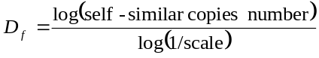 (1)
As an example, the Koch Snowflake is a self-similar fractal object composed by 4 copies of itself at the magnification 1/3. Using the formula, the Koch Snowflake fractal dimension will be: log(4)/log(3)≈1.26. In the study presented below, the self-similar dimension was used to validate the accuracy of algorithms.
The german mathematician Felix Hausdorff suggests one of the most accepted ideas for evaluating the fractal dimension: being proportional with the minimum number of cubes N(s), of a given size s, needed to cover the measured object:
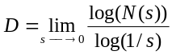 (2)
In practice, this limit converts slowly, thus is used an alternative way: if
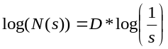 (3)
is the equation of a line with D-slope, the (log(N(s), log(1/s)) curve will be traced (known as the log-log curve), then by linear regression (the least square method) the slope D of the curve will be computed; this is in fact the fractal dimension [6]. This method is referred as the box-counting algorithm [7, 8] and consists in:
- covering repeatedly the fractal figure with equal size squares (s-size)
- numbering every time how many sqares contain points of the figure, this number is N(s)
- the log-log curve is traced and the slope of it’s liniest portion will be the box-counting dimension.

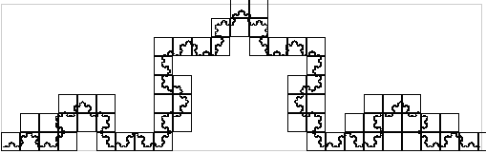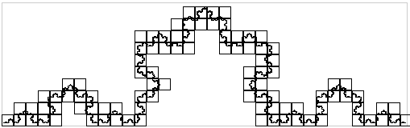
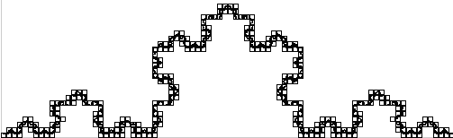

Fig. 3. The Koch Snowflake covered with squares of decreasing size. The small the coverage square will be, more details of the object will be covered.
For the Koch Snowflake the log-log curve will provide the dimension 1.26.

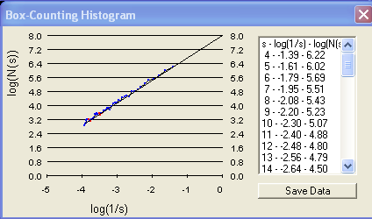

Fig. 4. The log-log curve provides the box-counting fractal dimension 1.2612

Fractal dimension measures the complexity of an object; it grows, as the shape is more irregular, as it can be seen in the table below. This observation will be very useful in order to characterize mammographic lesions.

MAMMOGRAPHIC LESIONS ANALYSIS

BI-RADS classification

BI-RADS (Breast Imaging Reporting and Data System) is a very complex system proposed by The American College of Radiology (ACR) in order of classification of mammographic lesions. The scope of BI-RADS system is to standardize mammography reporting in order to reduce confusion in breast imaging interpretations and facilitates outcome monitoring.

BI-RADS system consists in five categories from 1 to 5; each of them characterizes a kind of mammographic lesion and implies a certain action as a treatment. Shortly, the first three categories [9] are referring to negative cases or probably benign finding for which a short interval follow-up is suggested. BI-RADS 5 – characterize the lesions having a high probability of being cancer. The analyse propose in this paper concerns BI-RADS 4 category which characterize the lesions that do not have the characteristic morphologies of breast cancer but have a definite probability of being malignant. In those cases, the radiologist may appeal to a biopsy.

Hypothesis and experiments

When categories a mammographic anomaly, the radiologist has to observe several properties of the lesion:
- the contour’s shape
- localization
- dimension
- density
- number and bilarity of anomalies
- presence or absence of associated microcalcifications.

One of the most important features in categorising a mammographic anomaly is the contour’s shape [10]: a regular contour is associated to a benign case, while an irregular shape characterizes a malign lesion. On the other hand, the fractal dimension grows with the irregularity of the shape; this could be an essential observation in order to classify the BI-RADS 4 lesions, with no need of further investigations or biopsy. The fractal dimension may provide a tool for classification: the lesions with a regular contour are more probably benign, while the lesions with an irregular contour are more probably malign.

A statistical experiment was developed on a lot of 30 cases. The hypothesis was tested on these cases of BI-RADS 4 classified lesions, 18 benign cases and 12 cancers provided by the Medical Imaging Department of Clinical Institute Fundeni, Bucharest.

Each mammogram were analysed using an original software, fully described elsewhere [11], following the steps:
- the radiologist traces a FAR (Focussed Attention Region), using a mobile cursor. The size area can be 64X64, 128X128, 256X256 or 512X512. The selection must contain the anomaly and it is based on radiologist’s experience.
- the image is binarized using a threshold between 1-255 gray level: all pixels whose gray level is greater or equal to the threshold will be transformed in white, the rest will become black. At this point, the forms inside the image are white on a black background.
- the contour is automatically traced: once the image is binarized, the next step is to trace an outline of the white areas: all the white pixels, which have at least one neighbor black, will become part of the contour (every pixel has 8 neighbors: N, NE, E, SE, S, SV, V, NV). The rest of pixels will be transformed in black.

(a) 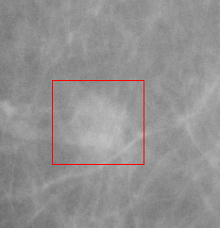(b) 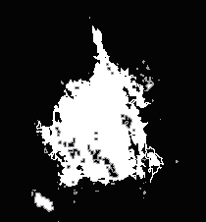
(c) 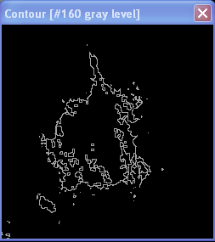
(d) 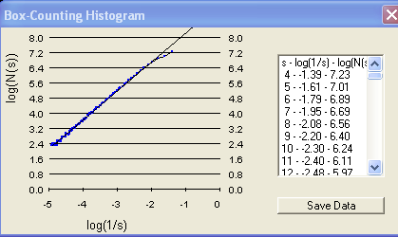

Fig. 5. (a) Step 1: a FAR is traced by the radiologist. (b) Step 2: the FAR is binarized; the white pixels are part of the form on a black background. (c) Step 3: the contour is traced - an outline of the white areas is obtained. (d) Step 4: The box-counting algorithm will provide the 1.36- fractal dimension.

- the fractal dimension of the outline will be computed using the box-counting algorithm. The result will be 1.36

The results of 30 cases of BI-RADS 4 classified lesions are as follows: the benign lesions have lower fractal dimension, between 1-1.50, while malign lesion have higher dimension, between 1.35-2.

Table 1. The fractal dimensions on 30 mammographic lesions

Lesions | Fractal dimension | Cases
Benign  (18 cases) | <1.4 | 16 (89%)
Benign  (18 cases) | >1.4 | 2 (11%)
Malign  (12 cases) | <1.4 | 1 (8%)
Malign  (12 cases) | >1.4 | 11 (92%)

In the figure 6, the statistical result based on fractal study is presented.
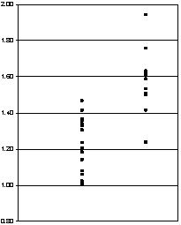

Fig. 6. The fractal dimensions distribution on 30 mammographic lesions.

CONCLUSION

Fractal theory deals with irregular contour objects, which cannot be described in the terms of Euclidian geometry. Irregularity degree is evaluated through the fractal dimension, which can be computed using image processing. The box-counting algorithm is an efficient method for estimating the dimension of a fractal object.

The presented application, from biomedicine, involves non-invasive techniques based on processing mammographic images. The method allows diagnosing mammographic cancer and it is based on two observations:

- the fractal dimension grows as the irregularity of the object grows;
- regular outline of a lesion is associated to a benign lesion, while irregular outline is associated to a malign lesion.

The hypothesis that cancers have higher fractal dimensions than benign lesions was tested on 30 cases and the results are encouraging.

Similar results have been achieved by the authors in other areas of interest like botanic (species classification), textile industry and food industry.

For further work, two directions are traced:
- using fractal dimension as an indicator of the evolution in time of mammographic findings. Structure modifications suffered by mammographic lesions will involve modifications of the fractal dimension; primary observations yield to the idea that the evolution of fractal dimension could be an indicator for prediction on the follow-up state of the lesion.
- additional studies show that the fractal dimension, which is a quantitative measure, can be used for retrieval in image databases [12, 13, 14]. Mammographic findings are characterised by a fractal dimension; searching a lesion in a mammographic database could be reduced to searching numbers in matrices.

REFERENCES

[1] Mandelbrot B. „The fractal geometry of nature”, Freeman, New York, 1983
[2] Hutchinson J., "Fractals and Self-Similarity.", Indiana Univ. Journal Mathematics, 35, 1981, pg. 713-747
[3] Landini G., J. W. Rippin, “How important is tumor shape? Quantification of the epithelial/connective tissue interface in oral lesions using local connected fractal dimension analysis”, Journal of Pathology 179, 1996, pg. 210-217
[4] Vasilescu C., Herlea V., Talos F., Ivanov B., Dobrescu R., “Differences between intestinal and diffuse gastric carcinoma: A fractal analysis”, Proceedings of the Interdisciplinary Approach of Fractal Analysis Symposium (IAFA), Bucharest, Romania, 2003, pg. 249-254
[5] Sari-Sarraf H., S. Gleason, K. Hutson, K. Hubner, “A Novel Approach to Computed Aided Diagnosis of Mammographic Images”, 3rd IEEE Workshop on Applications of Computer Vision, 1996
[6] Harris J. W., H. Stocker, "Hausdorff Dimension", "Scaling Invariance and Self-Similarity", "Construction of Self-Similar Objects.", cap. 4.11.1-4.11.3, Handbook of Mathematics and Computational Science, Springer-Verlag, New York, 1998, pg. 113-135
[7] Nezadal M., O. Zmeskal, M. Buchnicek, „The box-counting method: Critical Study”, Nostradamus 2000, Prediction Conference, 2000
[8] Crisan D., "Fractal features extraction in medical imaging using the Quadtree tehnique", Cercetare stiinţifică. Sesiunea cadrelor didactice, Universul Juridic, Bucuresti, 2003
[9] http://www.birads.at, Breast Imaging Reporting Data System.
[10] Lesaru M., „Analiza mamografiilor”, note de curs, 2005
[11] Crisan D., " Image processing using fractal techniques", PhD Thesis, Politehnica University of Bucharest, 2005
[12] Dobrescu R., Talos F., Vasilescu C., “Using fractal dimension for cancer diagnosis” – VIPromCom-2002 Conference, Zadar, Croatia, 2002
[13] Dobrescu R., Ionescu F., “Fractal dimension based technique for database image retrieval”, Proceedings of the IAFA Symposium, Bucharest, Romania, 2003, pg. 107-112
[14] Dobrescu R., Vasilescu C., “Interdisciplinary Applications Of Fractal And Chaos Theory”, Academia Română, Bucuresti, 2004

